**Performance Optimizations in C#**

### **UseConfigureAwait(false) when possible**

ConfigureAwait(false) is a valuable C# performance trick that can help prevent deadlocks in your async code and improve efficiency by not forcing continuations to run on the original synchronization context.

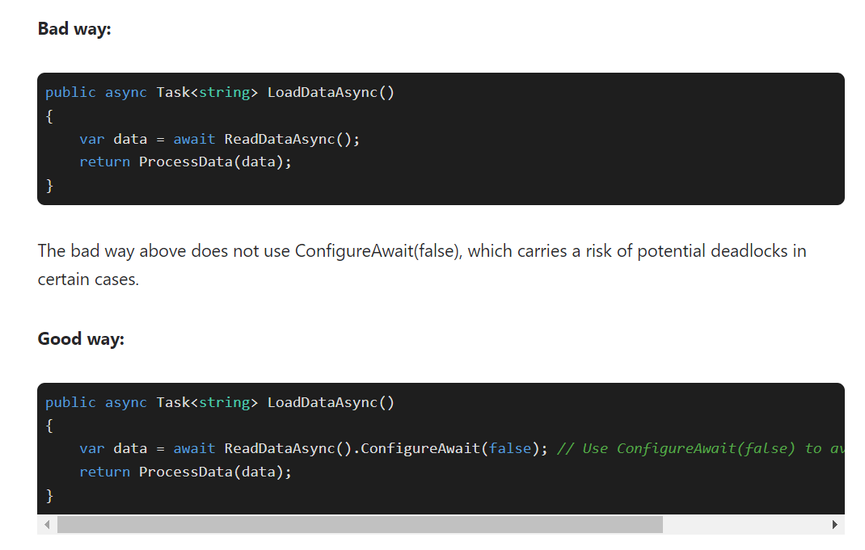

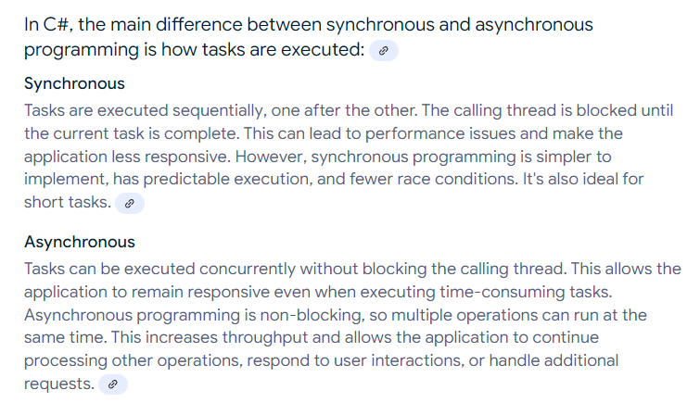

### **Implement data caching with in-memory cache**

Utilizing in-memory caching can drastically reduce time-consuming database fetches and speed up your application.

In the bad way above, product data is fetched from the database every time the [method](https://www.bytehide.com/blog/method-usage-csharp) is called. This can cause significant performance degradation, especially if the database is located remotely or is under heavy load.

The good way demonstrates the use of in-memory caching to store product data and reduce time-consuming database fetches. Utilize MemoryCache to cache frequently requested data and improve performance. This is a .NET performance optimization technique that helps to speed up data retrieval and reduce the load on your database server.

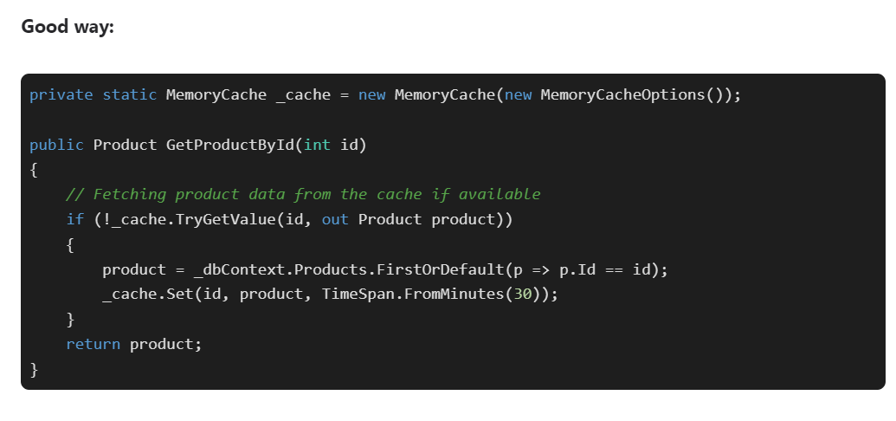

## Use For loop instead of foreach

## Always use Stringbuilder for String concatenation operations

The advantage of String is that it is immutable: once constructed, the contents of a string instance cannot change anymore. This means that you pass strings by reference without making copies all the time.

For example, suppose you would pass a StringBuilder to a class. Then you could change the contents of that StringBuilder afterwards, and confuse the class. So the class would need to make a copy to make sure that the content doesn't change without it knowing about it. With a String this is not necessary, because a String is immutable.

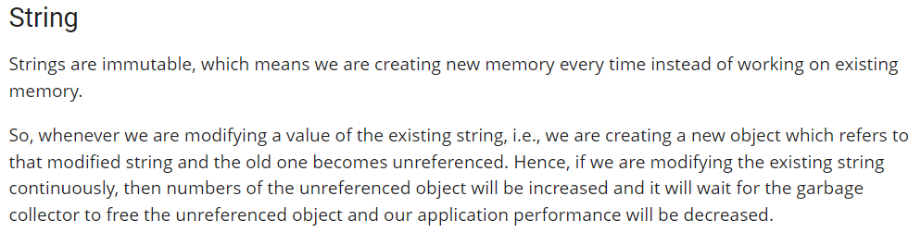

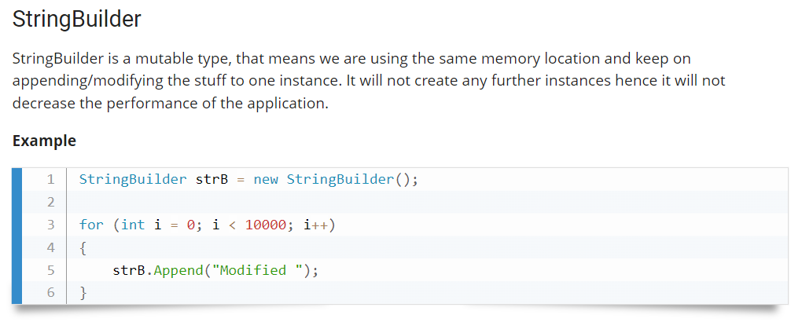

### **Use IEnumerable instead of Lists for Large Collections**

In C#, Lists are an efficient way to store and manipulate collections of objects. However, using IEnumerable for extensive collections can be more efficient since it avoids the overhead of creating and maintaining the List object.



### **Use LINQ for Filtering and Sorting**

 LINQ provides powerful tools for filtering, sorting, and manipulating collections. LINQ can be more efficient than manually iterating over a collection and performing operations on each item.

### **Asynchronous Programming**

Asynchronous programming is a technique that allows your code to continue executing while waiting for a long-running operation to complete. This can be particularly useful when working with I/O operations, such as reading and writing files or making web requests.

In C#, asynchronous programming is implemented using the async and await keywords

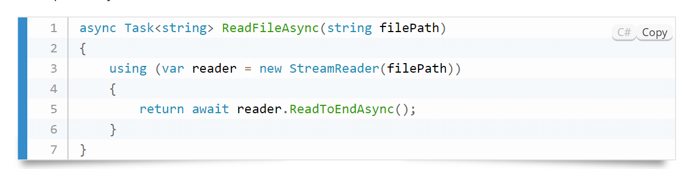

In this example, the ReadFileAsync method uses the StreamReader class to read the contents of a file. The await keyword indicates that the method should wait for the ReadToEndAsync method to complete before continuing execution.

### **Parallel Processing**

Another technique for improving the performance of your C# code is parallel processing. Parallel processing allows you to execute multiple tasks simultaneously, using multi-core processors to achieve faster results.

In C#, parallel processing is implemented using the Parallel class. Here's an example of parallel processing:

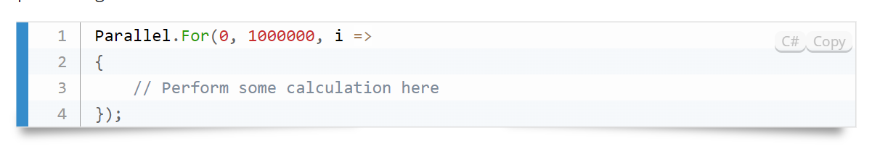

In this example, the Parallel.For the method is used to perform a calculation in parallel. The method takes three parameters: the starting value, the ending value, and a delegate that calculates each value in the range.

### **Use Generics**

Generics are a powerful feature in C# that allows you to create reusable code. By defining a class or method with a generic type parameter, you can create a type-safe, reusable component that can work with various data types. This can help improve performance by reducing the duplicated code you need to write.

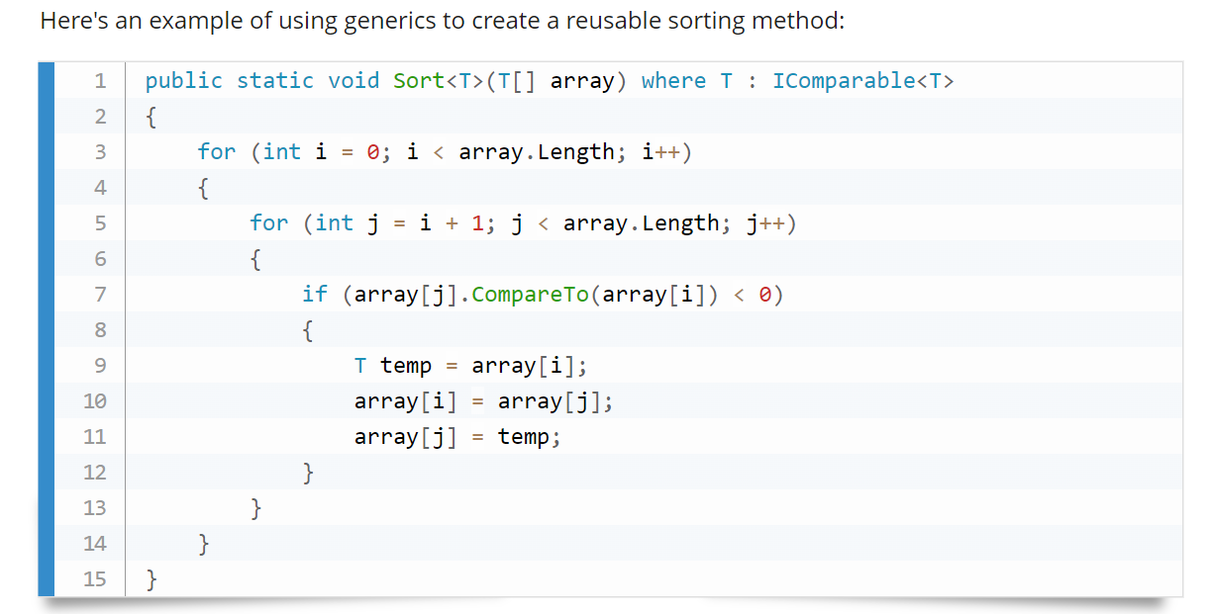

### **Use Interfaces for Loose Coupling**

 Interfaces provide a powerful mechanism for loose coupling between components. By defining interfaces for services or functionality, you can ensure that components can be easily swapped out or replaced without affecting the rest of the system. This approach can lead to better code performance by minimizing the impact of changes on the system as a whole. For example, consider the following interface that defines a generic repository for accessing data:

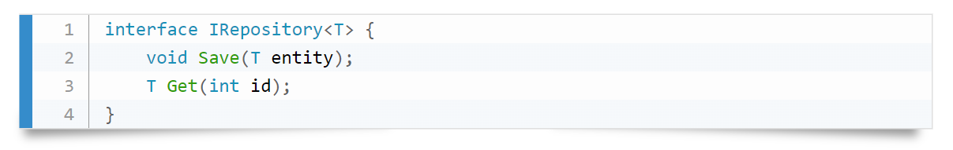

This interface can define a generic data access layer that can be easily replaced or updated without affecting the rest of the system.

### **Choosing the Right Data Types**

### Mistake: Developers sometimes default to using generic types like List<object> without considering the specific data types involved.

### Solution: Select the most appropriate data type to avoid unnecessary boxing and unboxing operations. For instance, use List<string> instead of List<object> when dealing with strings.

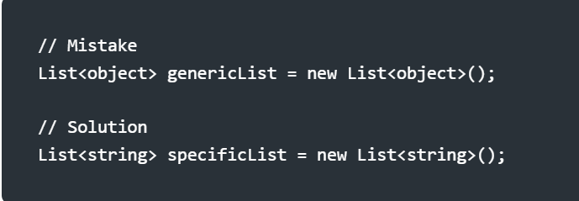

### **Avoiding Magic Numbers**

### Mistake: Hardcoding numbers without explanation can make code less readable and maintainable.

### Solution: Replace magic numbers with named constants or enumerations to improve code clarity.

### **Proper Resource Disposal**

### Mistake: Neglecting to dispose of resources explicitly, such as database connections or file streams.

### Solution: Implement the IDisposable interface or use the using statement to ensure proper resource cleanup.

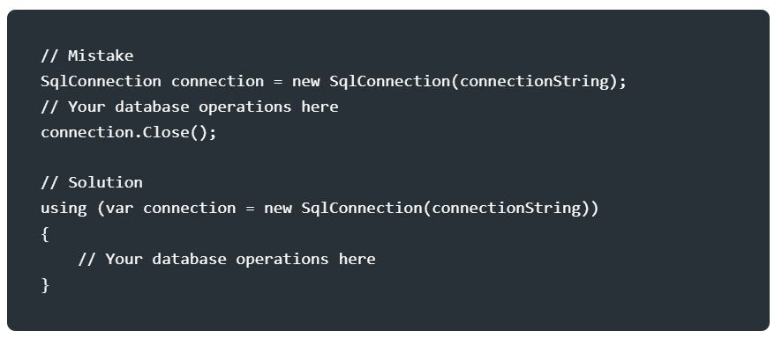

### **Efficient Logging Practices**

### Mistake: Logging excessively or inappropriately can impact performance and hinder issue diagnosis.

### Solution: Log only essential information at the appropriate log levels. Utilize logging frameworks like Serilog or NLog, and ensure logs are stored or transmitted securely.

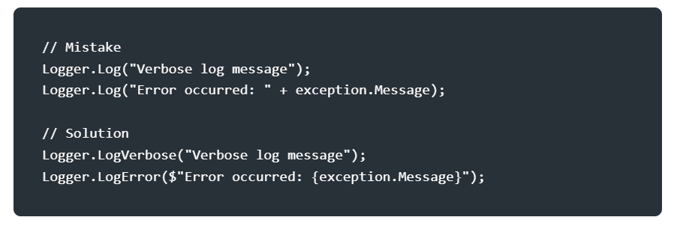

**Multithreading and Asynchronous Programming**

To achieve parallelism and improve responsiveness, multithreading and asynchronous programming are invaluable.

The Task Parallel Library (TPL) and the async/await keywords enable efficient utilization of multiple threads and asynchronous execution.

By leveraging these capabilities, you can perform computationally intensive or I/O-bound operations concurrently, leading to faster code execution and a more responsive user interface.

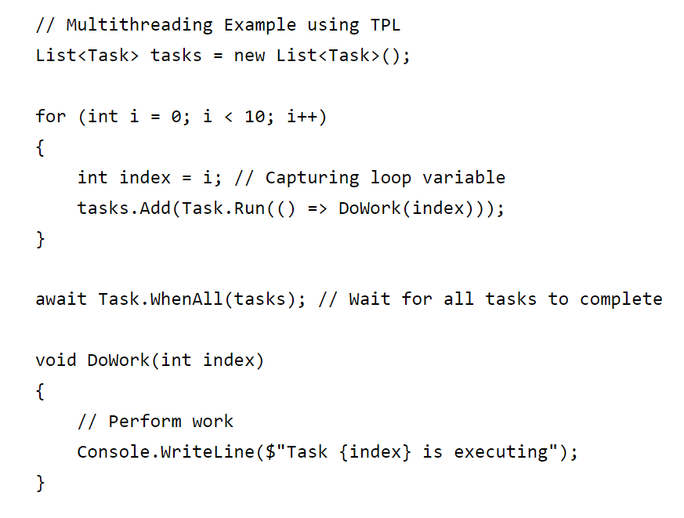

**Code Profiling and Optimization Tips**

* Avoid string concatenation in loops as it can create excessive memory allocations. Instead, use StringBuilder for efficient string manipulation.
* Minimize object creation within loops by moving object creation outside the loop or reusing existing objects.
* Take advantage of compiler optimizations, such as inlining and loop unrolling, to reduce function call overhead and improve performance.
* Refactor your code regularly to eliminate redundant or inefficient operations, resulting in cleaner and faster code.
* Leverage caching at different levels, such as database query results or computed values, to reduce costly operations